**Software Design – Homework 8**

Github: <https://github.com/kbarnewolt/kbarnewolt_HW8.git>

Azure: <https://brave-ocean-06ef62310.azurestaticapps.net>

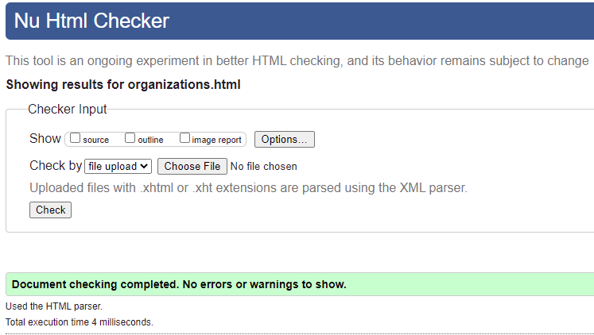**Index.html Organizations.html**

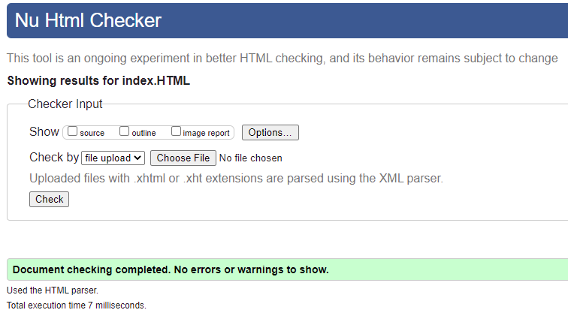

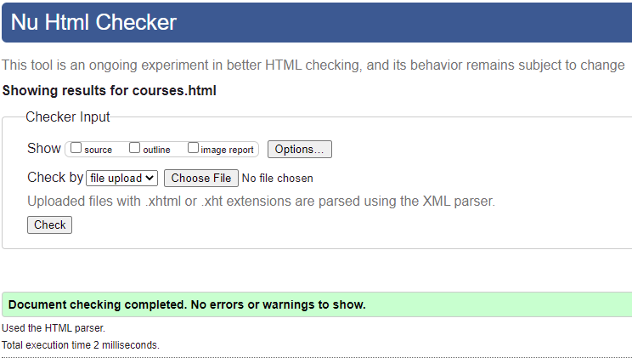**Technical Skills.html Courses.html**

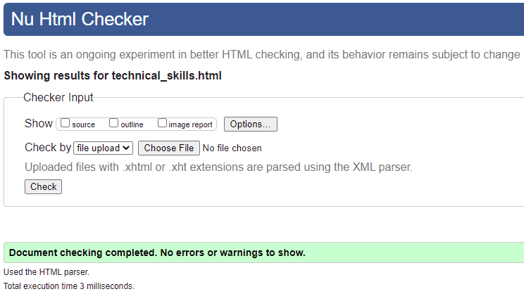

**Stylesheet.css**

